**CAP 454: LINUX AND SHELL SCRIPTING - LABORATORY**

**CONTINUOUS ASSESSMENTS (C.A)-3**

**ST_NAME: - EKHLAKH AHMAD**

**REG NO.: - 12209166**

**ROLL NO.: - RD2215B67**

**SECTION: - D2215**

**GROUP: - 2**

**Q.1. Write a shell script to check whether the entered number is even or odd. Also execute any 10 vi cmds**

Process: -

* Open VMWare software.
* And open Linux terminal.
* 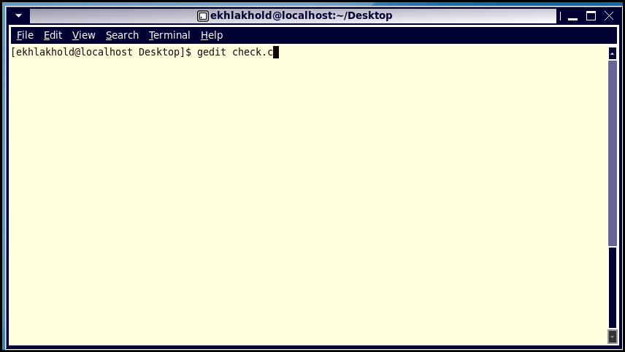Type gedit check.c
* Then press Enter key.
* Type some command according to need.
* And save it

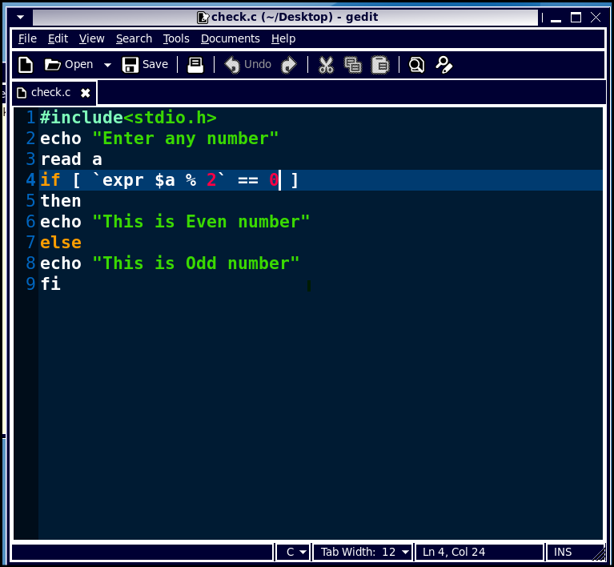

* Again open terminal.
* Give permission of file with chmod u+x check.c
* And run file with command ./check.c

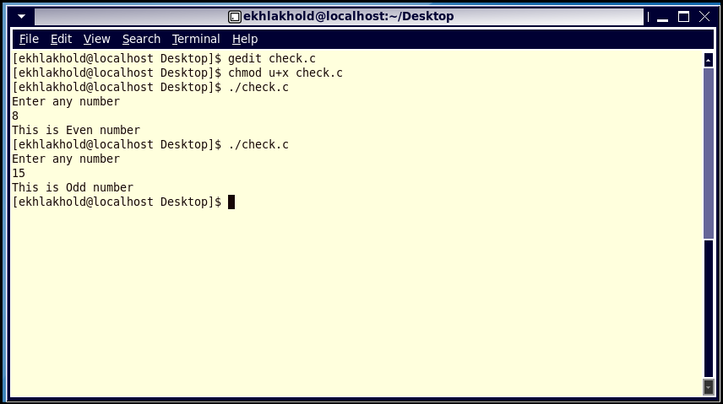

**Execute any 10 vi Command.**

* Open terminal in Linux.
* Type vi Ekhlakh.txt
* Then press Enter key.
* Press i (i for insert mode).
* Any some text as you need.
* Press “esc” key and “:wq” then press enter key.
* Type a🡪 add text after cursor.
* 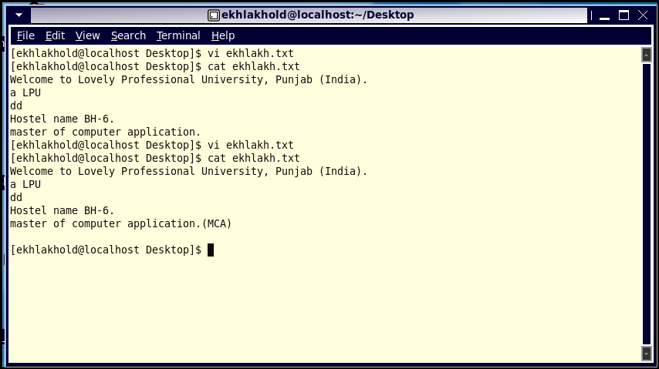See after master of computer application add (MCA)
* 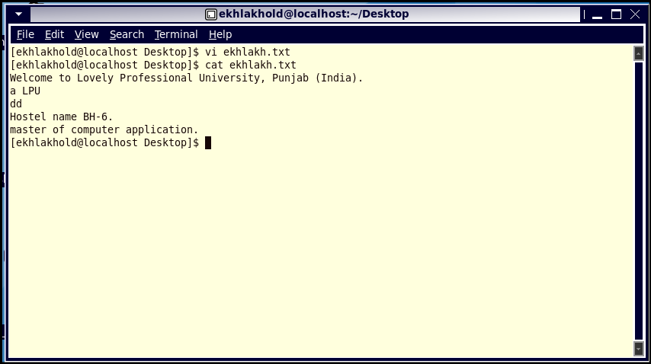Type A🡪 add text end of line.
* Type u🡪 Undo last change.
* Type dd🡪 delete line.
* Type r🡪 replace character.
* Type R🡪overwrite character from cursor.
* Type D🡪 delete line after cursor.
* Type dw🡪 delete word.